Discovery Education
Digital media (videos and more) to support instruction.
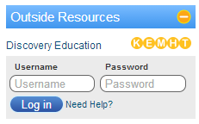
Creating Your Account
- Go to www.gpb.org/education.
- Scroll toward the bottom. Look for Outside Resources and click on Discovery Education. Our passcode for GIVE West is E69E-34E6

Searching for Content and Downloading Videos
- Use the search box at the top of the page. You can easily narrow by grade, subject, or media type.
- You can also search by Curriculum Standards and/or do an advanced search.
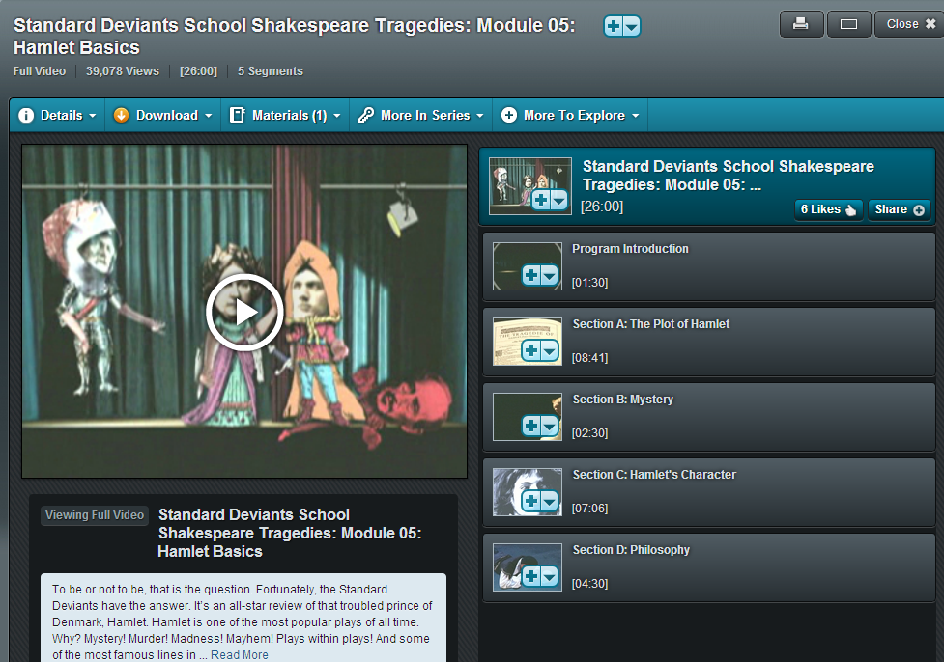
- There are many different types of content – full videos, video segments, images, learning guides, reading prompts, etc. You can filter by type after starting your search by using the “Narrow My Results” box on the left side of the screen.
- You can download and save videos to your Home folder that you are interested in showing to your classes. Show the saved file to your class; using this file instead of the website prevents slow load times that can happen when streaming video. Please note, not all videos can be downloaded.

Tips
- Use the tabs at the top of the video box to find teacher guides, related content, etc.
- You can also collect your video clips and other content you like in My Content. Click on the down arrow next to the video title to save them. Anything you save in My Content will be saved in your account so you don’t have to search again for content you like.
- Closed Captioning is available for some videos. Look for the CC icon underneath the video clip to check availability.
- There are many more tools available in Discovery Education, such as the Builder Tool for creating quizzes and assignments. The Teacher Center tab has great resources as well. Click the Help tab in the upper right corner for tutorials.

